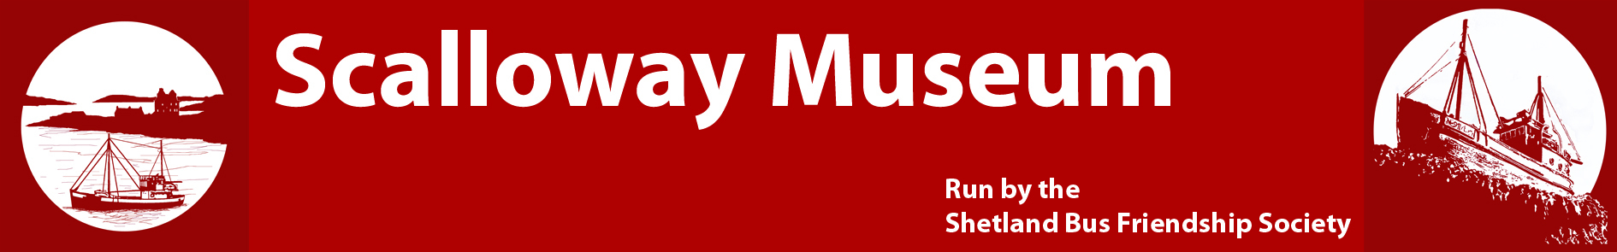

The Shetland Bus Friendship Society

The Shetland Bus Friendship Society was formed in 2001 to cement the links between Shetland and Norway forged during World War 2 and to keep the memory of the Shetland Bus alive.

In 2003 the Society built a memorial on the seafront in Scalloway dedicated to the memory of 44 Shetland Bus men who gave their lives fighting for Norway’s freedom. Every year the Society organises two wreath laying ceremonies at the memorial to honour the war dead - on Norwegian Constitution Day 17th May, and on Remembrance Sunday in November.

When the Society was invited to take over ownership and management of Scalloway Museum, suitable premises were located in Scalloway and converted. The museum was officially opened by the former Norwegian Prime Minister Jens Stoltenberg on 17th May 2012.

The museum has artefacts and interpretive displays on the history of Scalloway, including an extensive display dedicated to the Shetland Bus.

The new reference room facility in the museum opened in April 2014, and is available for research by appointment. It houses the collection of books and documents given to both Shetland Bus Friendship Society and Scalloway Museum.

Our museum displays are updated and maintained each year. This ongoing work is entirely voluntary and we thank you for your support.

Membership Secretary

Registered Charity No: SC032686 – Scottish Charitable Incorporated Organisation

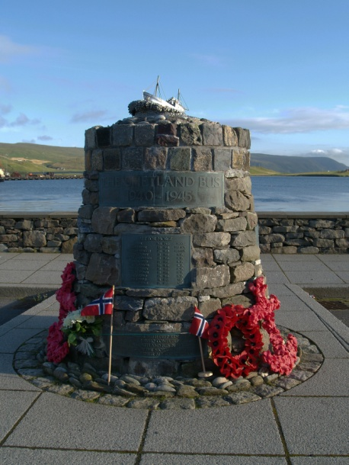

SHETLAND BUS FRIENDSHIP SOCIETY

MEMBER/FRIEND
APPLICATION FORM

Registered Charity No: SC032686 – Scottish Charitable Incorporated Organisation

SHETLAND BUS FRIENDSHIP SOCIETY
MEMBER/FRIEND APPLICATION FORM

I wish to become a Member/Friend of the Shetland Bus Friendship Society. Please see ‘Options’ on next page for the difference between Members and Friends.

Please tick one box below to select your preferred option
Member (Children under 16 years of age cannot become Members)
Friend
Title | Full Name | Gift Aid | Signature (if Gift Aid) | Date
 |  | YES/NO
If you are a UK taxpayer, the value of your donation/fee can increase by at least 25% under the Gift Aid scheme – at no additional cost to you!
I confirm that I am a UK taxpayer. Please treat all donations or membership fees I make to the Shetland Bus Friendship Society as Gift Aid until further notice. To confirm eligibility please complete the boxes above.

Please be aware that you must have paid an amount of income and/or capital gains tax at least equal to the amount of tax reclaimed by all charities on all your donations in the tax year (6th April to 5th April). Other taxes such as VAT and Council Tax do not qualify. Please let us know if your tax circumstances or name/address change so that we can update our records.
To pay annually by Standing Order: Set up a Standing Order with your bank payable to: Shetland Bus Friendship Society,
Sort Code: 80-08-82, A/C No: 00392517.
Please ensure you use your name as the Reference.

To pay via PayPal: Go to the “Support Us” page in our website (www.scallowaymuseum.org), click on ‘Donate’ and follow the PayPal instructions.

Please tick box to confirm your agreement to the charity retaining your contact details.

ADDRESS* _____________________________________
_____________________
_____________________

POSTCODE* ____________________________________

*Required for Gift Aid and Membership

E-MAIL ___________________________________________________

Please indicate your preferred method for us to contact you: Email Letter
Please Indicate Payment Method: Cash/Cheque/Standing Order/PayPal (Delete not applicable)
Forms can be returned via email to: membership@scallowaymuseum.org
or posted to the address below:
Membership Fee £10 (if applicable) | £
Donation (if applicable) | £
TOTAL | £
Membership Secretary
SBFS
Scalloway Museum
Castle Street
Scalloway
Shetland, ZE1 0TP

Registered Charity No: SC032686 – Scottish Charitable Incorporated Organisation
OPTIONS

The differences between the two options are shown below:

Rights/Responsibilities | Member | Friend
Right to attend and vote at the Annual General Meeting | YES | NO
Must act in interest of the charity | A legal responsibility of members | Not applicable
Must ensure the charity acts in a manner consistent with its charitable purposes | A legal responsibility of members | Not applicable
Can be elected as a trustee | Trustees are legally required to be members | NO
Membership records have to be kept and made available to charity trustees or members when requested | A legal requirement with former members details being retained for 6 years | Not required
Membership Fee | Annual membership fee of £10 required by our constitution | Not required
Donations | Optional | Optional
Season Ticket (value £3) | YES | NO
Annual Newsletter | YES | YES

To become a ‘Friend’ of the Shetland Bus Friendship Society please provide your name, email address and donation amount. If you do not have an email address it would help us contact you in future if you provide your contact details. If you want your donation to be valid for Gift Aid please provide your address details which legally have to be shared with HMRC.
If you are interested in becoming more actively involved in the charity’s operations, attend meetings or become a trustee you will need to register as a ‘Member’, provide your name, address details, a £10 membership fee and optionally an email address, if you have one.
If you become a member you should be aware that the charity is legally required to retain your name and address details and make these available, when requested, to charity trustees and other members. Address details will be omitted if the request is made by a member. Details of former members must be retained for 6 years.
All name and address details will be retained by the charity on a secure database which will only be accessible to authorised trustees. These details will not be used for marketing purposes or shared with other organisations or individuals unless we are legally required to do so (see above).

Registered Charity No: SC032686 – Scottish Charitable Incorporated Organisation

